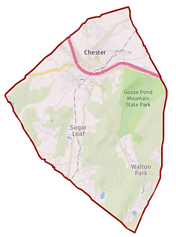
Town of Chester
Zoning Board of Appeals
Chairman: Gregg Feigelson

Members: Julie Bell
Dan Doellinger
Bob Favara
Walter Popailo
Alternate: Tom Atkin

Attorney: Robert Dickover
Secretary: Julie Tiller

1786 Kings Highway
Chester, NY 10918
(845)-469-7000 x338

Agenda
Aug 27, 2020 |  | 7:00 PM |  | Location: Zoom Teleconference  Information below
Time | Item
7:00 PM | Pledge of allegiance
 | Adoption of minutes |  | (as applicable)
 | Other business |  | (as applicable)
 | Item |  | Applicant / Address / Zone |  |  | Summary
 | Public hearing |  | Ryan Marrone  6 Derose Lane  S/B/L 34-1-2 SR-2 Zone |  |  | Area variance  24’ above ground pool
 | Application Review |  | Jason & Kelli Maass  8 Park Drive  S/B/L 19-1-17 SR-2 Zone |  |  | Area variance  2 car free standing garage
 | Application Review |  | Flower/Sandstrom  73 Dug Rd  S/B/L 24-2-10 AR-3 Zone |  |  | Area variance  for side yard
 | Application Review |  | Jeffrey Sapanaro  1351 Kings Highway  S/B/L 13-3-3.1 LB-SL Zone |  |  | Area variance  2 family dwelling
Join Zoom Meeting  https://us02web.zoom.us/j/87464261113  Meeting ID: 874 6426 1113  One tap mobile  +19294362866,,87464261113# US (New York)  +13017158592,,87464261113# US (Germantown) |  |  |  |  | Dial by your location  +1 929 436 2866 US (New York)  +1 301 715 8592 US (Germantown)  +1 312 626 6799 US (Chicago)  +1 669 900 6833 US (San Jose)  +1 253 215 8782 US (Tacoma)  +1 346 248 7799 US (Houston)  Meeting ID: 874 6426 1113  Find your local number: https://us02web.zoom.us/u/klrGVCBfr

